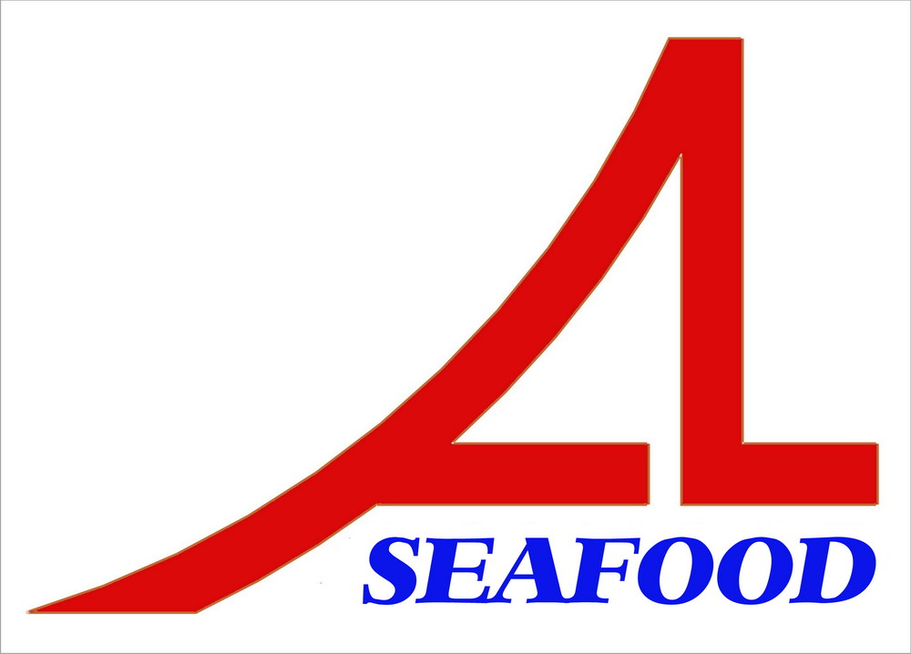AN LAC SEAFOOD CO.,LTD
LOT A14,4A STREET,HAISON INDUSTRIAL ZONE,DUC HOA DISTRICT,LONG AN PROVINCE,VIETNAM

AGREEMENT
Date : 04/10/2013
Party A : AN LAC SEAFOOD CO., LTD.

Address: Lot A14, 4A Street, Hai Son Industrial Zone, Duc Hoa District, Long An Province, Vietnam.

Tel/ Fax: 84-72-3850606 / 84-72-3850608
Represented by: Mr. NGUYEN THIEN DUY – Director

Party B : CHANG SU JUNG
Address: No.66-10, Sec.2, Nankan RD., Luzhu Township, TaoYuan County, Taiwan.
Tel.: Fax:

After discussion , it is must be mutually agreed by both parties to sign for agreement as follow :
After comparing , two parties agree with the prepayment : 14.588,80 USD (base on the advice of bank No.: 131004-218 dated : 04/10/2013 ) will be paid to contract No.: 01/AL-AP/13 with amount 3.496,80 USD and contract No.: 01/AL-YY/12 with amount 11.092,00 USD
The agreement have valid from the date was signed .
The agreement is made into 02 (two) originals in English , each party keeps 01 (one) original with equal value .

PARTY A PARTY B

NGUYEN THIEN DUY CHANG SU JUNG

